**Experiment No:** 13

**Experiment name:**  Page Replacement Algorithm

**Advantages:**

i.This algorithm is very simple to implement.

ii.The aging technique is implemented to reduce the starvation.

**Source Code:**

#include<stdio.h>

int main()

{

int i,j,n,a[50],frame[10],no,k,avail,count=0;

printf("Enter the number of Pages: ");

scanf("%d",&n);

printf("Enter the page number : ");

for(i=1; i<=n; i++)

scanf("%d",&a[i]);

printf("Enter the number of FRAMES : ");

scanf("%d",&no);

for(i=0; i<no; i++)

frame[i]= -1;

j=0;

printf("\n");

printf("tref string\t page frames\n");

for(i=1; i<=n; i++)

{

printf("%d\t\t",a[i]);

avail=0;

for(k=0; k<no; k++)

if(frame[k]==a[i])

avail=1;

if (avail==0)

{

frame[j]=a[i];

j=(j+1)%no;

count++;

for(k=0; k<no; k++)

printf("%d\t",frame[k]);

}

printf("\n");

}

printf("Page Fault is: %d",count);

printf("\n");

return 0;

}

**Result:**

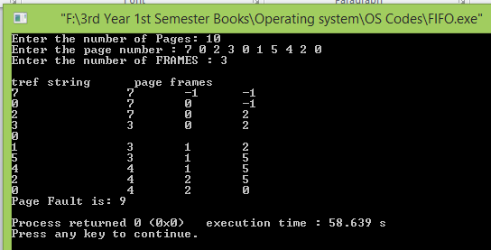

**Conclusion:**

This type of scheduling is one of the very basic algorithm for operating systems in computer which can be implemented through circular queue data structure. Our honorable teacher helped us by giving some important lecture which helped us to code these above method.